

TECH3650 Game Design and Development

Unit 4 Assignment 1

# Directions

Make a copy of this Google Document so you can edit it.

# Name

|  |
| --- |

# Game URL

* Name your experience TECH3650 Unit 4 [LASTNAME]
* Add **profpy** as a Collaborator with Edit access for grading purposes. If I can’t access your source code, I will not grade your submission!

|  |
| --- |

# Part 1

| Diagram 1 | Diagram 2 | Diagram 3 |
| --- | --- | --- |

Decide which ones you’d like to build. What parts do you need? Do these parts need to be unioned?

|  |
| --- |

### **Tips**

* If you’re going to combine parts, under Model, change the Rotate angle to 0 degrees. This will give you more flexibility when joining them together in a specific way.

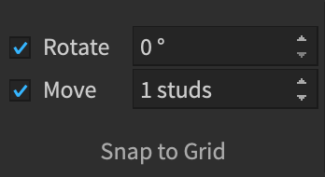

* You may find it easier to work with the parts on the ground. Use the Top Camera view (Diagram 1)
* Then you can union the parts together, and then rotate the part up. (Diagram 2)
* Make sure your item is Anchored.
* Playtest often! (Diagram 3) It may take experimentation to get your object rotating in the axis that you want.
* Note, the rotation will occur from the center of the object.

| **Source Code** |  |
| --- | --- |
| **Screenshots of Rotating Object** |  |

# Part 2

## **Problem 1**

Using a single while loop, write code that makes the Turtle follow this path.

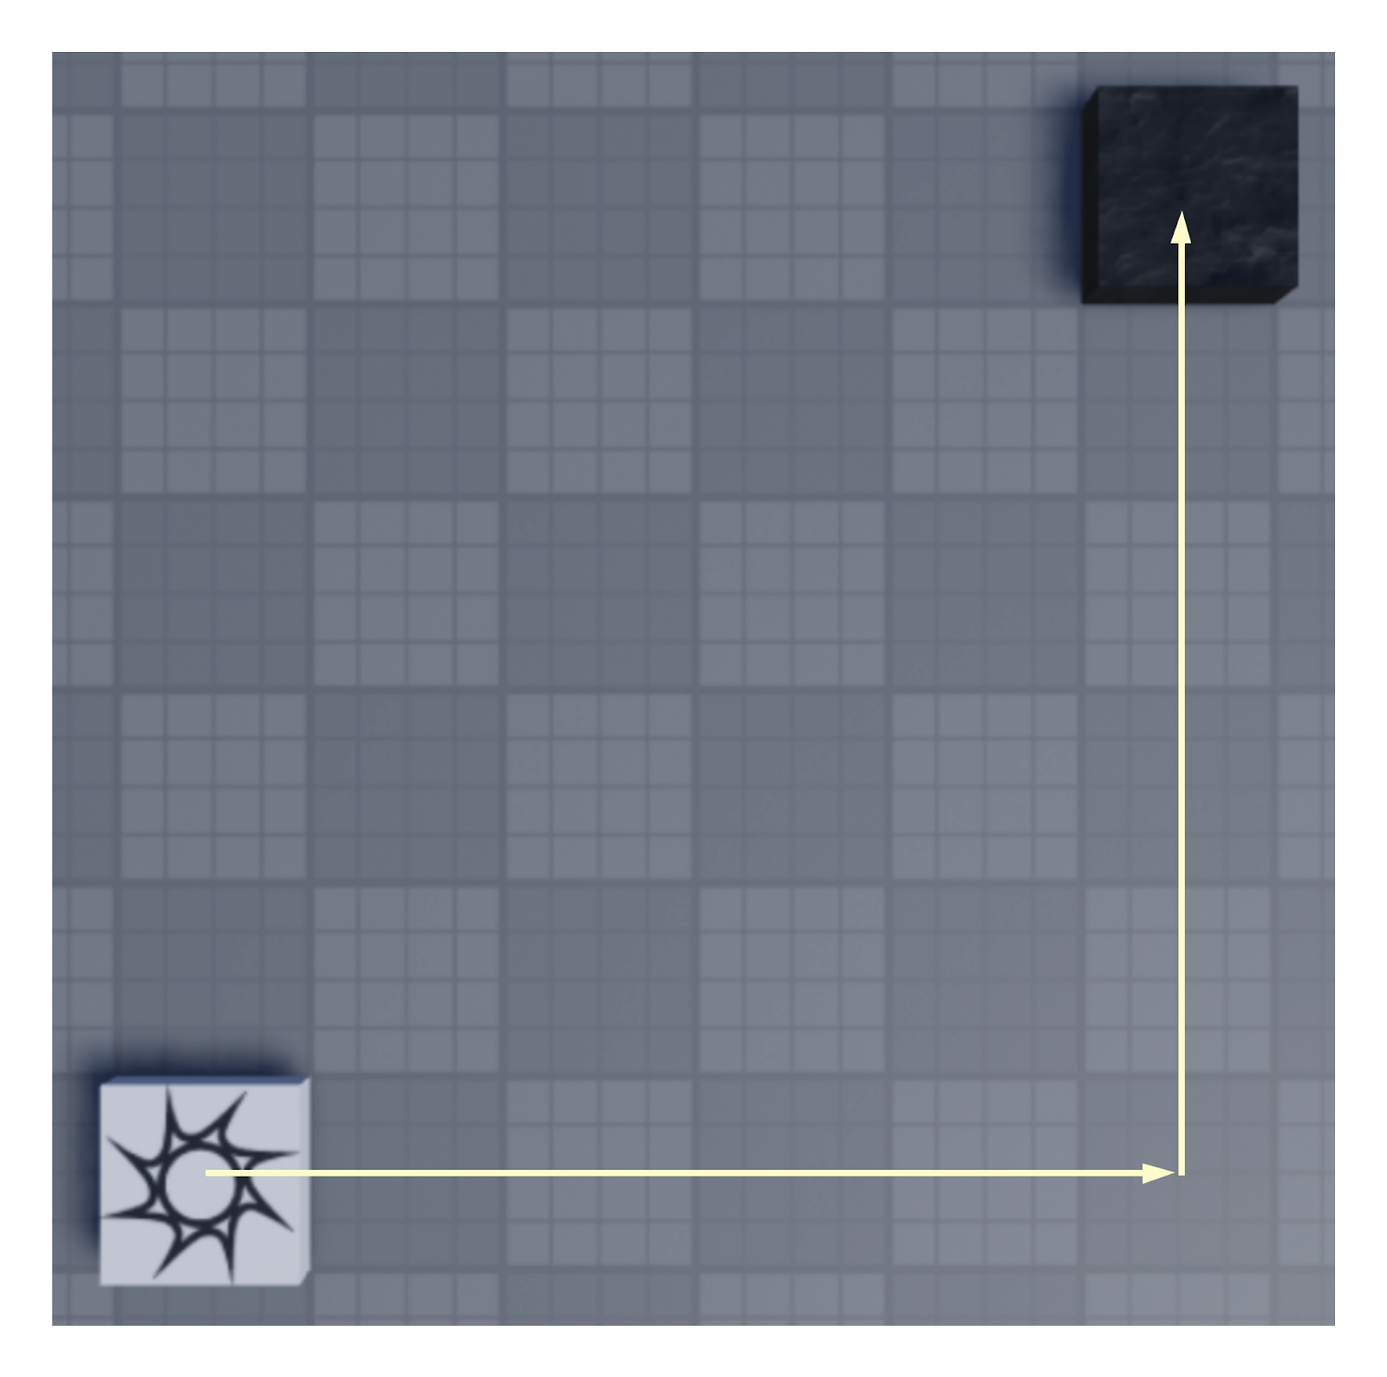

| **Source Code** |  |
| --- | --- |
| **Screenshots of Turtle making its way to the Destination** |  |

## **Problem 2**

Using a single while loop, write code that makes the Turtle follow this path. You may need two additional statements after the while loop ends.

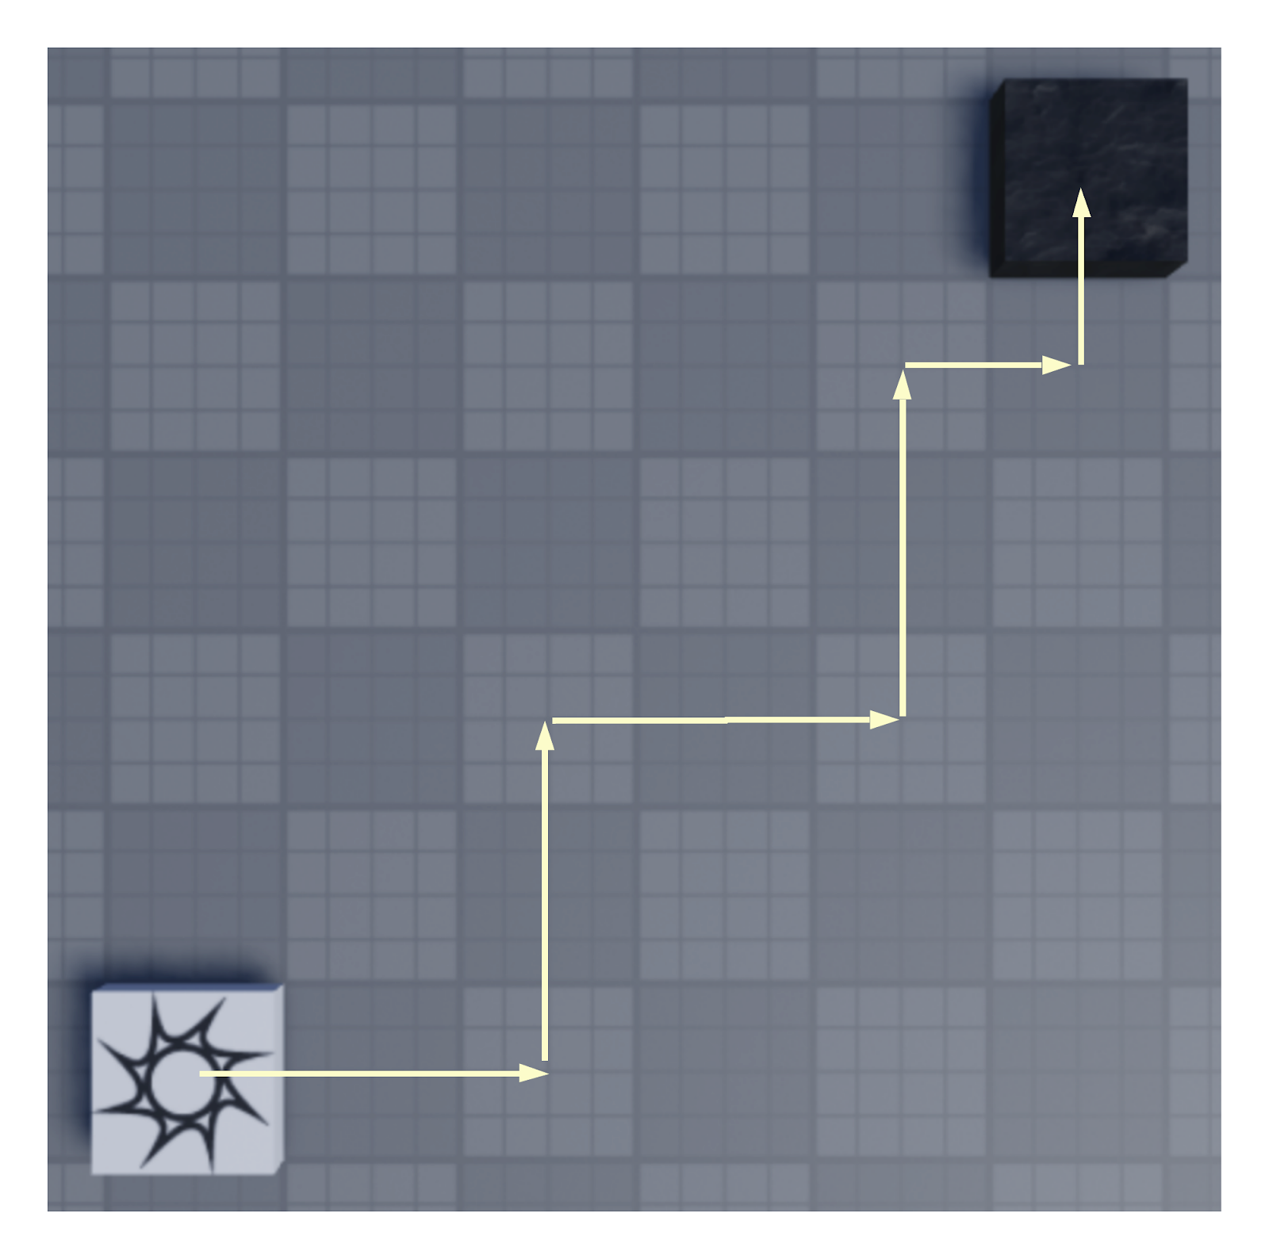

| **Source Code** |  |
| --- | --- |
| **Screenshots of Turtle making its way to the Destination** |  |

## 

## **Problem 3**

Using a single while loop, write code that makes the Turtle follow this path. You may need two additional statements after the while loop ends.

## 

| **Source Code** |  |
| --- | --- |
| **Screenshots of Turtle making its way to the Destination** |  |

## 

## **Problem 4**

Using a single while loop, write code that makes the Turtle follow this path.

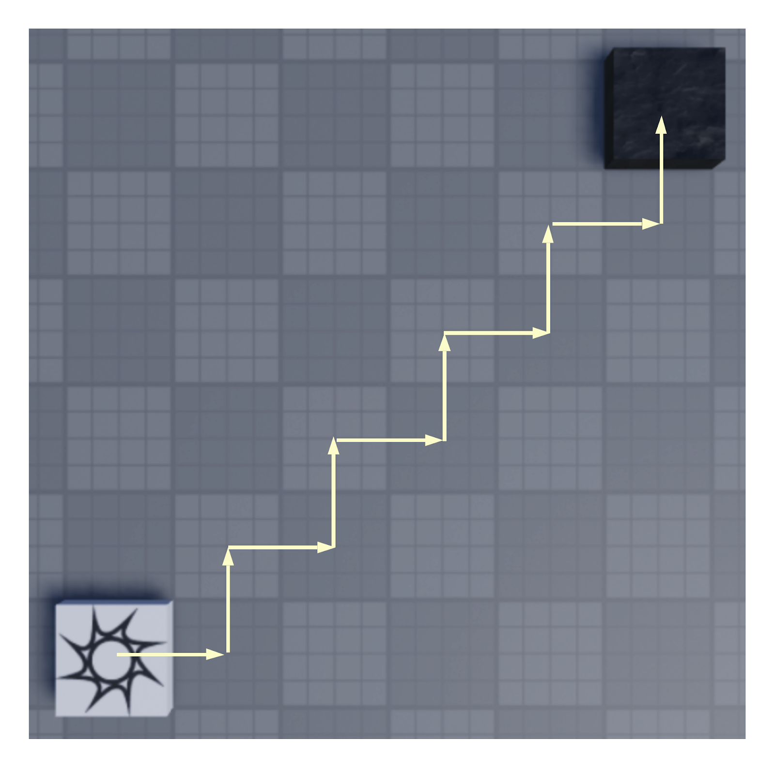

| **Source Code** |  |
| --- | --- |
| **Screenshots of Turtle making its way to the Destination** |  |

## 

# Part 3

## **Problem 1**

Let’s create a matchstick. In Workspace, add a Model. Models are container objects, meaning they group objects together.

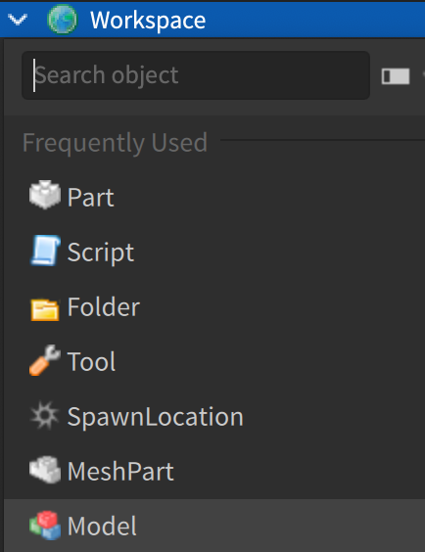

Rename the Model to Match.

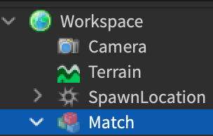

Create a 1x1x1 part to represent the tip of the match.

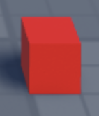

Place this part in Match. Rename the part Tip.

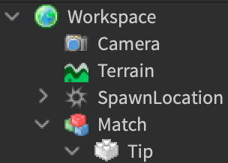

Add the Fire script from the example.

Note, if you named used the names above, the first line of code will be



If all goes well:

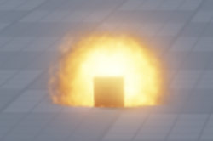

* Create another part and name it Base. (Diagram 1)
* Add this part to Match. (Diagram 2)

| Diagram 1 | Diagram 2 |
| --- | --- |

* Place the tip on top of the base. Note, both parts should be anchored.
* If all goes well, you should have a matchstick that looks like Diagram 4.

| Diagram 3 | Diagram 4 |
| --- | --- |

Create two while loops. In the first while loop, increase the size of the fire and in the second decrease the size of the fire.

| **Source Code** |  |
| --- | --- |
| **Screenshot of the Output** |  |

## **Problem 2**

Create a sphere of light that progressively gets brighter for 30 seconds and then gets dimmer for 30 seconds before turning off.

| **Source Code** |  |
| --- | --- |
| **Screenshot of the Output** |  |

## **Problem 3**

Create a sphere of light that is on for 60 seconds total and turns on and off randomly.

| **Source Code** |  |
| --- | --- |
| **Screenshot of the Output** |  |

## 

# Part 4

## **Problem 1**

Let’s roll the dice! Create a 4x4x4 part and name it Dice. Change the properties (Color, Texture) as you like.

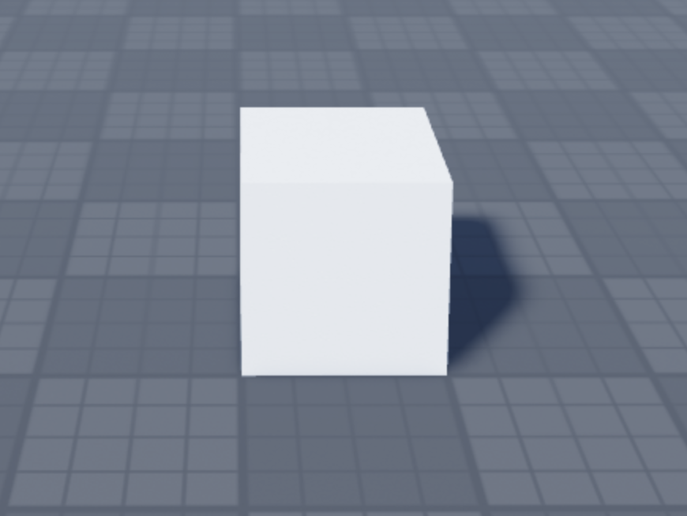

* Add a SurfaceGui. Rename this to Side1
  + Set the Face to Top.
  + Add a TextLabel
    - Size
      * X
        + Scale: 1
        + Offset: 0
      * Y
        + Scale: 1
        + Offset: 0
    - TextScaled: Checked
    - Text: 1

| Explorer | Dice |
| --- | --- |

* Repeat this for all 6 sides of the dice.
  + Duplicate Side1, change the Face, Change the text to 2 - 6.

Use this Chart to keep track of which Face corresponds to which number.

| **Face** | **Number** |
| --- | --- |
| Top | 1 |
| Back | 2 |
| Bottom | 3 |
| Front | 4 |
| Left | 5 |
| Right | 6 |

If all goes well, your cube should look similar to this:

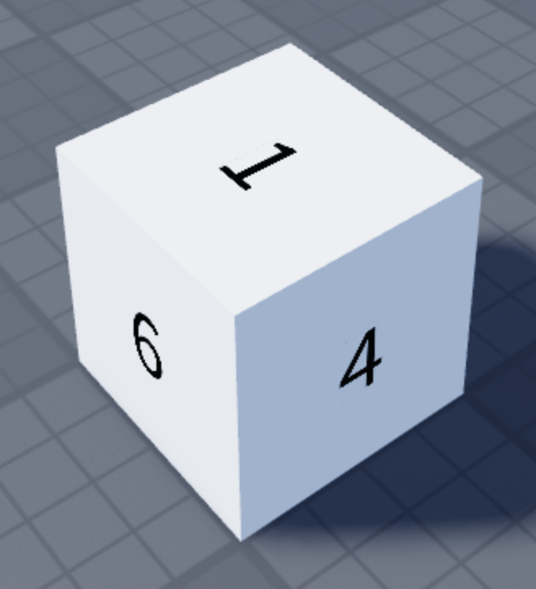

Using a repeat until loop, simulate rolling a dice.

Hints:

* To change the position of the dice use:
  + part.Position
* To spin the dice, use:
  + part.CFrame
* You may want to use math.random to set the number of iterations of the repeat until loop.

Playtest your code and make sure that in every roll, a different value is facing up.

|  |  |  |
| --- | --- | --- |

| **Source Code** |  |
| --- | --- |
| **Screenshot of the Output** |  |

# 

# Part 5

## **Problem 1**

Using a for loop that counts down, create a stack of blocks one on top of the other.

Think about what value needs to change in part.Position

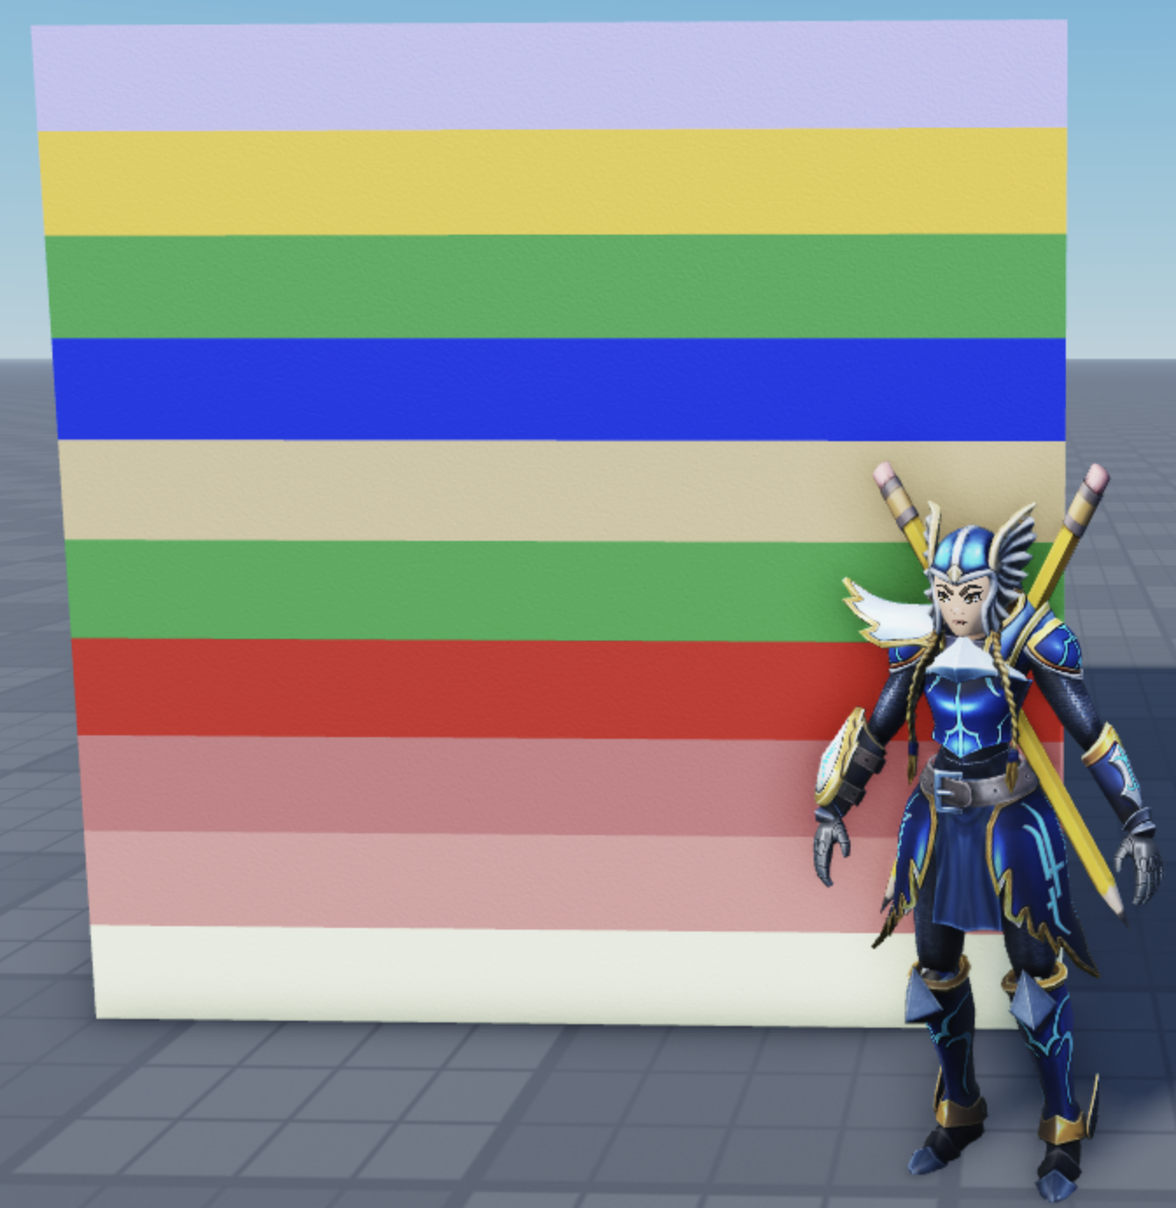

| **Source Code** |  |
| --- | --- |
| **Screenshot of the Output** |  |

# 

## **Problem 2**

Using a for loop that counts up, create a stack of blocks one on top of the other with each block getting smaller.

Think about what value needs to change in part.Position and part.Size

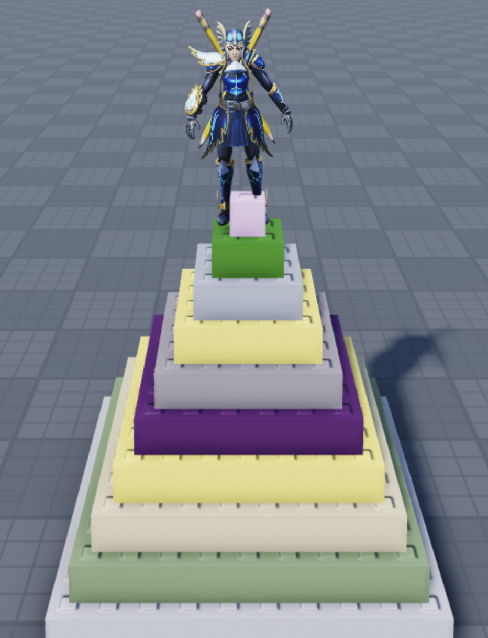

| **Source Code** |  |
| --- | --- |
| **Screenshot of the Output** |  |

# 

# 

# Rubric

| **0 points** | **10 points** | **20 points** | **25 points** |
| --- | --- | --- | --- |
| • no submission. | • partially answers the writing prompt | • partially answers the writing prompt meaningfully and thoroughly. | • answers the writing prompt meaningfully and thoroughly. |

# Points: 25

# Canvas Submission

Upload your submission as a **PDF** file. It is your responsibility to make sure that Canvas receives your submission successfully and that it is viewable in Canvas. If your submission is not viewable by Canvas because you did not upload your document as a PDF file, you will not receive credit for it.

